Lab 2: Hello World & Debugger

Victor Yuan

Microcontrollers and Embedded Systems

February 8, 2017

Introduction:

The Goal of this lab was to familiarize the programmer with the tools on how to debug a code with the IDE, Code Blocks.

Procedure:

Part 1:

Type in the provided given code. Compile and run the code.

Part 2:

Open up Code Blocks. Create a project file import the code and run the debugging tool. Insert a break point. While pulling up the CPU Registers and Memory dump window.

Code:

Given code from Part 1, typed into a textile and compiled and ran:

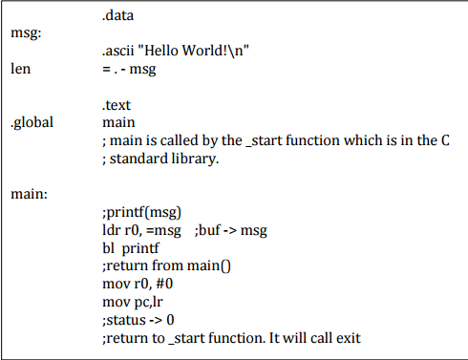

Results:

1. Monitor all changes made to register r0 and report the different values. What’s the significance of each value seen in r0?

R0 started at 0x2068c20 moved to 0xd to 0x0 and stayed there for the rest of the program.

1. What is the starting address of msg (in Hex) in memory?

Program being debugged:

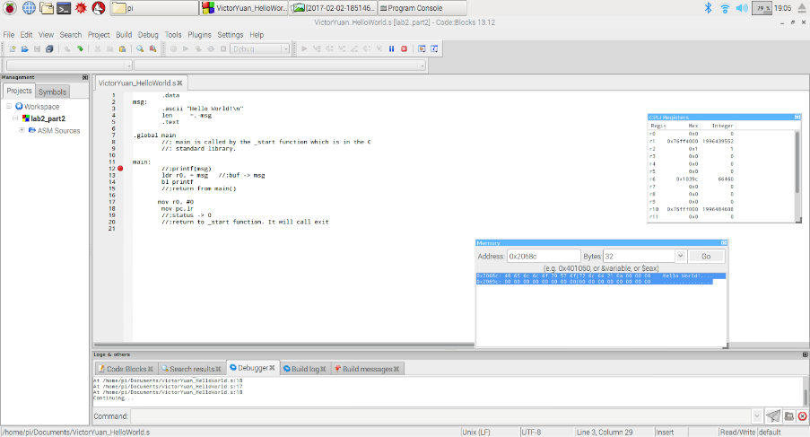

Zoomed in on Memory dump/search:

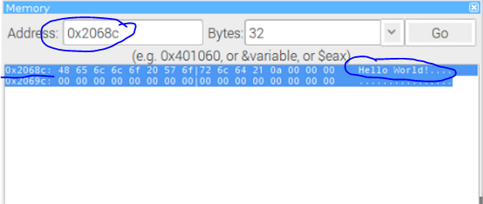

1. How did the program known to print each character until “\n” was reached?

“\n” represented in ASCII is 0a once 0a was read the program realized the special character and stopped.

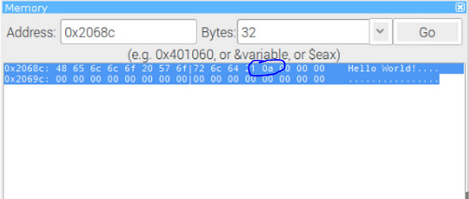

Conclusion:

Code Block was successfully installed onto the Raspberry. How to use a debugging tool was shown. Memory location of registers was shown.